A Project Report On

### Country Guide Web

Submitted in partial fulfilment of the requirements of the degree of

### (Internet of Things and Cyber Security Including Block Chain Technology)

**2022-23**

### SUBMITTED BY -

|  |  |
| --- | --- |
| ***Priyush B. Khobragade*** | **52** |
| ***Jai Malay*** | **57** |
| ***Mayuri Thakare*** | **72** |
| ***Akshay S. Lohar*** | **54** |

**PROJECT GUIDE**

### Prof. Ulka Shirole



Department of Computer Science and Engineering (Internet of Things and Cyber Security Including Block Chain Technology)

A. C. Patil College of Engineering, Kharghar, Navi Mumbai University of Mumbai

2021-2022

Jawahar Education Society’s

A. C. Patil College of Engineering, Kharghar

CERTIFICATE

This is to certify that the Project entitled

“**Country Guide web**”

is a bonafide work of

Submitted to the University of Mumbai in partial fulfilment of the requirement for the award of the degree of Second Year Engineering in Computer Science and Engineering (Internet of Things and Cyber Security Including Block Chain Technology)

**(Prof. Ulka Shirole) Prof. S. P. Pawar**

Guide Head of Department

**Dr.V.N. Pawar**

Principal

Mini Project Approval

This Mini Project entitled “**Country Guide web”** by **Priyush B. khobragade (52.), Mulay Jai Ganesh (57), Lohar Akshay Suresh (54), Mayuri Thakare(72) for** the course Mini Project– 1 B is approved for the degree of **third Year Engineering** in **Computer Science and Engineering (Internet of Things and Cyber Security Including Block Chain Technology)**

**Examiners**

**1………………………………………**

(Internal Examiner Name & Sign)

**2…………………………………………**

(External Examiner name & Sign)

Date: Place:

# Abstract

The purpose of Country Guide Website is to automate the existing manual system by the help of computerized equipment’s and full-fledged computer software, fulfilling their requirements, so that their valuable data/information can be stored for a longer period with easy accessing and manipulation of the same. The required software and hardware are easily available and easy to work with.

This Website, as described above, can lead to error free, secure, reliable and fast management system. It can assist the user to concentrate on their other activities rather to concentrate on the record keeping. Thus, it will help organization in better utilization of resources. The organization can maintain computerized records without redundant entries. That means that one need not be distracted by information that is not relevant, while being able to reach the information.

The aim is to automate its existing manual system by the help of computerized equipment’s and full-fledged computer software, fulfilling their requirements, so that their valuable data/information can be stored for a longer period with easy accessing and manipulation of the same. Basically, the project describes how to manage for good Performance and better service for the client.

# UNDERTAKING

We declare that the work presented in this project “**Country Guide Web”** l submitted to the Computer Engineering Science (IOT) Department AC Patil College of engineering Kharghar Navi Mumbai to fulfil the requirements for the award of Degree in Computer Engineering and is my original work. I have to plagiarize or submitted the same work for the award of any other degree or examination. In case this undertaking found incorrectly I accept that my degree may be unconditionally withdrawn or may be punishable as per the norms of Institute.

|  |  |  |
| --- | --- | --- |
| **Name of Students** | | **Roll No**. |
|  |
| Priyush Bhimrao Khobragade | | 52. |
| Mulay Jai Ganesh | | 57 |
| Lohar Akshay Suresh | | 54 |
| Mayuri Thakare | | 72 |

PLACE-

DATE-

# ACKNOWLEDGEMENT

I have taken efforts in this project. However, it would not have been possible without the kind support and help of many individuals and organizations. I would like to extend my sincere thanks to all of them.

I am highly indebted to their guidance and constant supervision as well as for providing necessary information regarding the project x also for their support in completing the project. I would like to express my gratitude towards my parents x my team members for their kind co-operation and encouragement which help me in completion of this project.

I would like to express my special gratitude and thanks to my faculties for giving me such attention and time. My thanks and appreciations also go to my colleague in developing the project and people who have willingly helped me out with their abilities.

### INDEX PAGE

|  |  |  |
| --- | --- | --- |
| **SR.NO.** | **TITLE** | **PAGE NO** |
| 0. | Acknowledgement | 06 |
| 1. | Abstract | 04 |
| 2. | Chapter 1 Introduction   * 1. Basic Idea   2. Motivation   3. Problem Statement & Objectives | 10 |
| 3. | Chapter 2 Literature Review   * 1. Survey of Existing System   2. Limitation Existing system or research gap   3. Mini Project Contribution | 13 |
| 4. | Chapter 3 Proposed System   * 1. introduction   2. Architecture/ Framework   3. Algorithm and Process Design   3.3 Project Planning  3.3 Details of Hardware & Software | 15 |
| 5 | Chapter 4 Database | 25 |
|  | Chapter 5 Testing | 30 |
| 6. | Chapter 5 Coding | 32 |
| 7. | Chapter 6 Output Screenshots | 45 |
| 8. | Chapter 7 Conclusion | 47 |
| 9. | References | 49 |

**List of Figures:**

* **Working**
* **Framework**
* **Version**
* **Country guide in Architecture**
* **error correction**
* **Structure**
* **Finder pattern**
* **Home screen**
* **Whether page**
* **Historical page**
* **County info**
* **Login authentication**
* **Firebase**

**List of tables:**

1. **Table 01**
2. **Table error correction**
3. **Test**

# CHAPTER 1 INTRODUCTION

### INTRODUCTION

The " **Country Guide Website** " has been developed to override the problems prevailing in the practicing manual system. This software is supported to eliminate and, in some cases, reduce the hardships faced by this existing system. Moreover, this system is designed for the particular need of the company to carry out operations in a smooth and effective manner. The application is reduced as much as possible to avoid errors while entering the data. It also provides error message while entering invalid data. No formal knowledge is needed for the user to use this system. Thus, by this all it proves it is user - friendly Travel Website, as described above, can lead to error free, secure, reliable and fast management system. It can assist the user to concentrate on their other activities rather to concentrate on the record keeping. Thus, it will help organization in better utilization of resources.

Every organization, whether big or small, has challenges to overcome and managing the information of Flag, country name, Capital, conciliate, Language, currency, Map, Historical place etc. This is designed to assist in strategic planning, and will help you ensure that your organization is equipped with the right level of information and details for your future goals. Also, for those busy executive who are always on the go, our systems come with remote access features, which will allow you to manage your workforce anytime, at all times. These systems will ultimately allow you to better manage resources.

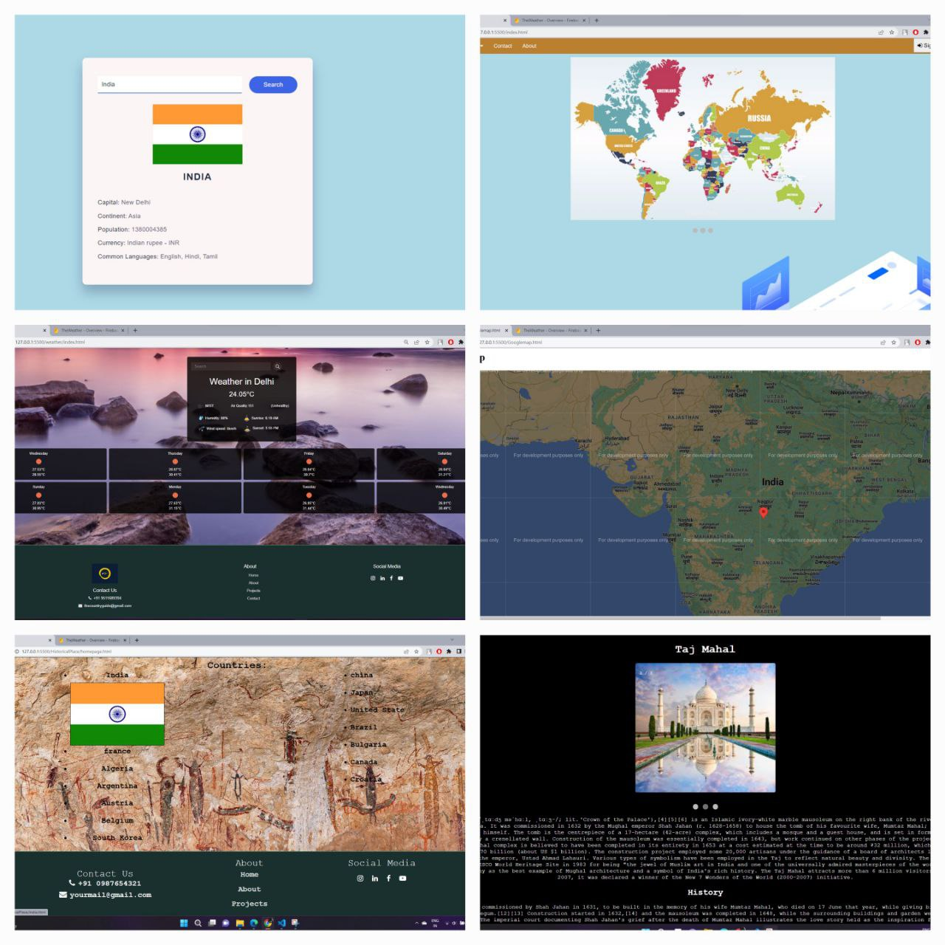

**FIG 1.1 working flow**

* 1. **Motivation**

At first, we would like to express our sincere thanks and gratitude to our advisor Professor Ulka Shirole for her excellent guidance and motivation for doing our Country guide web project. Her kind encouragement, compassionate and invaluable detailed suggestion and supervision throughout the phases of project development, presentation, and paper organization have helped us to successfully accomplish the paper. Secondly, we would like to express our gratitude to Mr. Priyush for helping us understanding the basic tools and use of programming languages and other components for developing the project and guided us to achieve our desired goal. Finally, we are sincerely grateful to our parents, family, and friends, who give their valuable suggestions and support to complete the project. The whole research work would not be possible without the active encouragement from all of them.

### 1.3Problem Statement & Objectives:

Problem Statement Generating a Country Guide web and developing a website reader which will be used for Traveling, Educational purpose process integration. We are going to develop an Website which would be able too. This project is intended to small businesses which would use this technology for marketing purpose

The purpose of our project is to provide the basic idea on some common information in the different country’s that the travelers, Students need to Education purpose.

**1.4 Objectives:**

The first objective of this thesis work is to study the concept of Country Guide Web in detail, which involves the development history and the definition. Furthermore, the purpose of our project is to provide the basic idea on some common information in the different country’s that the travelers, Students need to Education purpose.

# CHAPTER 2 LITERATURE REVIEW

**LITERATURE REVIEW**

### 2.1Overview of Country Guide web:

The number of people interested in tourism, Education, is increasing day by day. They travel to Bangladesh for different purposes such as visiting, religious, job, business and so on. Statistics indicates “Tourism is the strongest and largest industry in the global economy world, generating an estimated 11% of the global gross domestic product (GDP) and employing 200 million people and serving 700 million tourists worldwide-a figure which is expected to double by the year 2020” .

2.2 **Travelers’ Requirement:**

Although people can get some general information regarding traveling over the internet, it is sometimes problematic for the newcomers in a place to get familiar with the new environment. Basically, they face difficulties in communicating and finding proper routing information and associated costs for distinct routes.

**2.3 Web Platform to Meet the Requirements**

Nowadays people have been moved so much into the modern technology that they really want an intelligent living environment along with intelligent objects which contain powerful infrastructure with the most desired features. Thus, Website have become very popular.

# CHAPTER 3 PROPOSED SYSTEM

## 3.1 Introduction:

Considering requirements and popularity of android device and app, we have come up with the idea of making a mobile browser for the student, foreigners and newcomers in one of the most attractive and tourist cities in India which is named Delhi, and our chosen mobile platform is Android which is open source, developed and distributed by Google.

**3.2 Country guide in Architecture:**

Some examples that relate the use of Country Guide Web with the architecture and educational framework are: 1. Basic Web-Link: This Web links a website related with architectural n**e**ws:

**FIG 3.1 3.2** **Country guide in Architecture**

The most common data linked to a Guide Web are:

* **URL:** Website, Google maps location, Historical places , YouTube video, social media data, etc.

## 3.3 Algorithm and Process Design:

The RestCountryAPI versions of the Guide web range from Version 1v to Version 3.5v. Each version has a different module configuration or number of modules. (The module refers to the adding the information in stapes wise.) "Module configuration" refers to the number of modules contained in a web, commencing with Version 1 up to Version 3.5v Figure shows the module configuration of the basic Country guide Web, a widely used mathematical error-correction method.

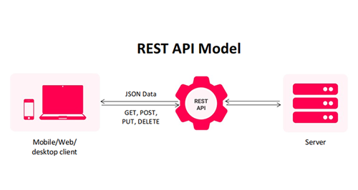

**FIG 3.2 REST API MODEL**

Three levels of error correction are available, higher level has high capability of recovery. Table 2 shows error-correction levels and their approximate ability of error correction. When selecting the level of error correction, environmental conditions as well as the desired size of the Country Guide Web need to be taken under consideration.

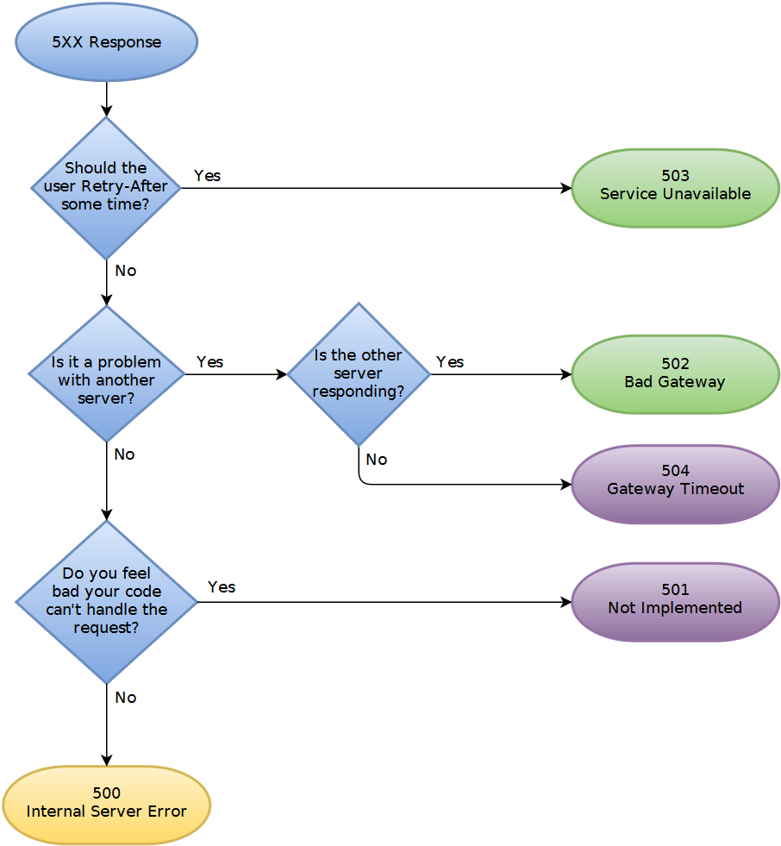

**FIG 3.3 Error-1**

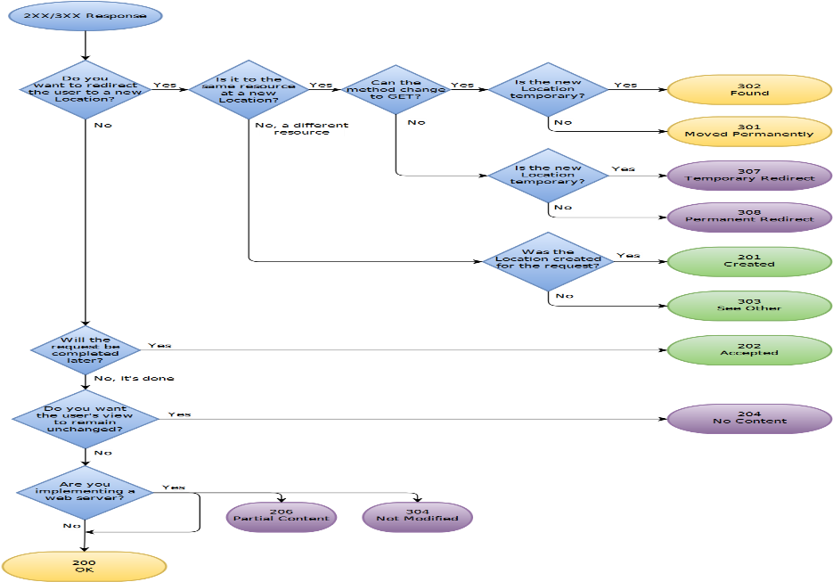

**FIG 3.4 Error – 2**

For example:

The server understood the request, but is refusing to fulfill it. Authorization will not help and the request SHOULD NOT be repeated. If the request method was not HEAD and the server wishes to make public why the request has not been fulfilled, it SHOULD describe the reason for the refusal in the entity. If the server does not wish to make this information available to the client, the status code 404 (Not Found) can be used instead

**3.4 *STRUCTURE OF A COUNTRY GUIDE WEB:***

Before you can start choosing, and using domain names it is useful to have an idea of how domains are structured, and what parts of the name are fixed and what parts you can choose yourself.

As an aid to explaining domain names and to help you to understand them we will compare them to something everyone is already familiar with.- your house address.

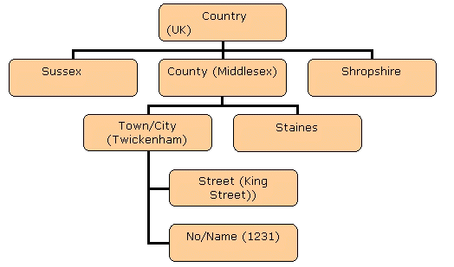

FIG 3.5 STRUCTURE OF A COUNTRY GUIDE WEB

**we examine a standard house address you see that it is divided into**:

* + - Country Name .
    - The address has a structure which is hierarchical starting at the top with the country. Figure 1 shows this structure.

FIG 3.6 **Structure Of Country Guide Web**

The purpose of a website is to present valuable information in an accessible way. This information is distributed amongst various internal pages that make up a website. Website structures define the architecture of a website for search engines and users alike.

The structure of a website basically means how all the different pages on a website are connected to each other. This can be accomplished using internal links, which present the hierarchy and organization of your website to the search engine algorithms.

**A good structure for a travel website has the following characteristics**:

* It has a dedicated landing page for each City / State the properties are located i.e. Villas in Florida
* It has a dedicated landing page for each specific area i.e. Villas in Miami
* For each property there is an optimized page (more on this below)
* To visualize the structure of your travel website, it should look like the diagram below.

‘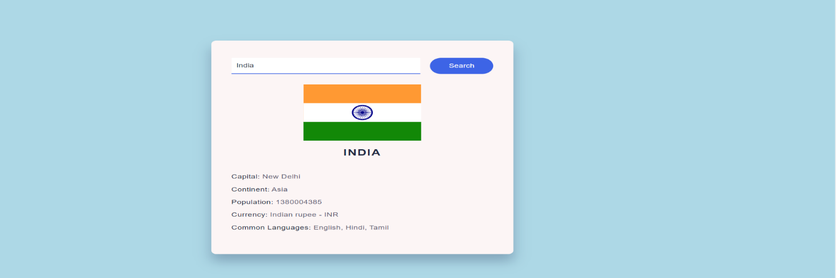

FIG 3.7 API data Show

### API :-

API is an acronym for **Application Programming Interface**. In simple words, we can say that an API delivers a user response to a system and sends the system’s response back to a user. One of the most common examples is weather apps, whenever we search the weather of any specific place the apps do not gather the information by themselves but the information is collected through the API of any weather service and the results are then displayed to us.

### API WORK :-

The working of APIs is simple as depicted in the below image, let’s understand it with a practical example. Suppose you are trying to log in to your GeeksforGeeks account from your device (System1) so when you enter your credentials then API makes a request to the GeeksforGeeks server (System2) and then API sends back a response to your device enabling you to log in to your account easily. So basically, API acts as a connecting channel that allows the transmission of data from system to system in a hassle-free manner.

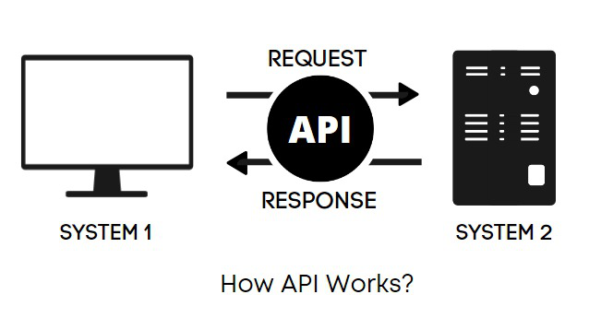

FIG 3.8 API WORK

### Why use API?

* APIs provide a huge amount of functionality, which can be used to develop our own applications or websites.
* APIs make our work faster and make the entire workflow smoother.
* APIs provide greater flexibility in delivering services and allows them to be shared and distributed more easily.
* *Hopefully, now the basics of APIs are clear, so let’s discuss some cool APIs that you can use in your projects.*

### 1. Bored API

Bored? Try using this API that will suggest different activities to fight off your monotonous lifestyle, the best part is that the activities are not bounded just to a particular topic but there is lots of diversity which make it interesting like*“Learn how to make a website”*, *“Organize a cluttered drawer”*, *“Plant a tree”*, *“Compliment someone”* and a lot more. In this era of “work from home”, this is an apt API that you can use to build an “activity generator” that generates random fun activities.

### 2. Meme Generator API – Imgflip

Who doesn’t like memes? Almost every social media platform is occupied by memes, even companies use memes for advertisements and increasing engagement with the audience. This API has a variety of range of meme templates that you can edit according to your choice and make memes easily.

### 3. Responsive Voice API

Are you interested in voice enabling your site with just a few lines of code? It doesn’t necessarily require machine learning and virtual reality. The responsive voice API allows you to transform any text into speech. As voice search is becoming an essential component of eCommerce and virtual assistants like Alexa and Siri are becoming more common so a project based on voice recognition would be quite interesting.

### 4. Meal DB API

It is an open, crowd-sourced database of recipes from around the world. If you are planning to make a food-related website then this API is perfect for you, it consists of different food items its ingredients, recipes with step-by-step instructions. It also suggests a variety of dishes by just mentioning the available ingredients.

### 5. NASA API

It provides many amazing APIs like you can get the weather on Mars, see photos of the space or listen to sounds of space. It also provides an API called Astronomy Picture of the day that shows one new picture from space every day.

### 6. Trivia Questions API – ****service****

This API consists of a collection of 156,800 trivia questions, which you can use to build your next side projects like a trivia or a quiz app. It has questions from various categories like television, animals, sports, food, quotations, and many more, it also has “stupid answers” categories which consist of questions that have answers which are correct but at the same time sounds stupid like :   
*Question: It’s the highest mountain in Kenya*  
*Answer: Mount Kenya*

### 7. Unsplash API

Most of us are familiar with the website Unsplash which provides high-definition images and photos for free that you can download and use for your projects but only a few know about the Unsplash API, you would be amazed to know that even unsplash.com runs on this API. So if you are planning to make a wallpaper app or an app that requires stock photos then this API is all that you need.

### 8. Quick Chart API

Charts make projects/reports visually more attractive. The Quick Chart API generates chart and graph images, these static chart images can be embedded in SMS, emails, reports, and chatbots. Charts are not the only thing; this API also generates QR codes and PDFs so you can even use this API for your next project.

### 9. OMDb API

The OMDb or Open Movie Database API is a RESTful web service that is used to obtain any movie-related information. This API offers methods for searching movies or TV shows by episodes, titles, ratings, keywords, and more. So if you are planning to make a project that requires movies or TV shows data or a movie search app then this API is a perfect fit as it is easy to use.

**WEATHER LOCATION: -**

FIG 3.9 Weather Location

The purpose of a website is to present valuable information in an accessible way. This information is distributed amongst various internal pages that make up a website. Website structures define the architecture of a website for search engines and users alike.

The structure of a website basically means how all the different pages on a website are connected to each other. This can be accomplished using internal links, which present the hierarchy and organization of your website to the search engine algorithms.

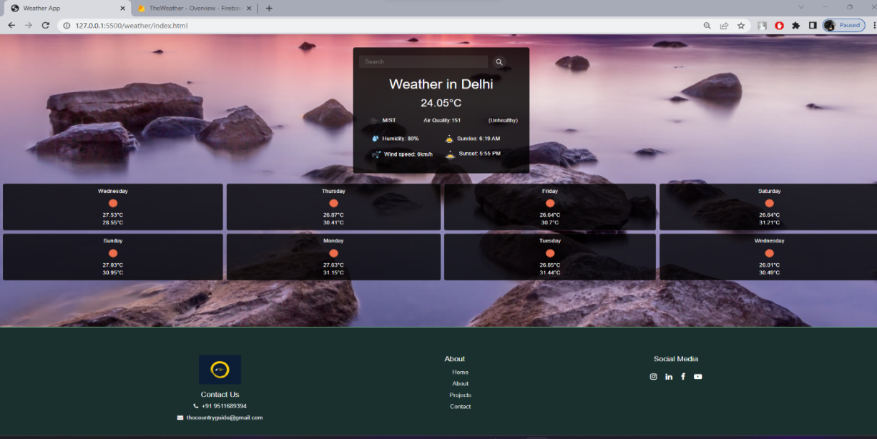

FIG 3.10 Weather Information

**SYSTEM PLANNING & SYSTEMS DEVELOPMENT LIFECYCLE (SDLC):**

We have chosen *“Iterative Life Cycle Model”* for developing this application, because an iterative life cycle model does not attempt to start with a full specification pf requirement. Instead, development begins by specifying and implementing just part of the software, which can then be reviewed in order to identify further requirements. This process is then repeated, producing a new version of the software for each cycle of the model. Here is the diagram of the iterative life cycle model which depicts its working flow.

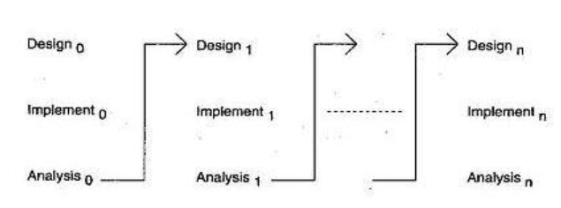

FIG. SDLC

**Few advantages for choosing the SDLC are –**

* In iterative model we are building and improving the product step by step. Hence, we can track the defects at early stages. This avoids the downward flow of the defects.
* Testing and debugging in smaller iteration is easy.
* In iteration model we can get the reliable user feedback. When presenting sketches and blueprints of the product to user for their feedback, we are effectively asking them to imagine how the product will work.
* Progress can be measured.
* In iterative model less time is spent on documentation and more time is given for designing.
* Risk are identified and resolved during iteration; and each iteration is an easily managed milestone. It supports changing requirements.

**User Requirement:**

The users of the system are members of the *“Country Guide Web* The users are assumed to have basic knowledge of the computers and internet browsing. The administrators of the system should have more knowledge of the internals of the system and is able to rectify the small problems that may arise due to disk crashes, power failures and other catastrophes to maintain the system. The proper user interface, user manual, online help and the guide to install and maintain the system must be sufficient to educate the users on how to use the system without any problems.

**GUI**

This application provides good graphical interface for the user and the administrator can operate on the system, performing the request task such as create, update, delete and also view every details.

* The user interface must be customizable by the administrator.
* All the modules provided with the software must fit into this graphical user interface and accomplish to the standard defined.
* The design should be simple and all the different interfaces should follow a standard template.
* The user interface should be able to interact with the other users.
* Design of registration page, log in page and also otp verification page is easy to understand for every user.

**Project Planning:**

**THE OVERALL PROJECT DESIGN CONSISTS OF:**

**HTML (HyperText Markup Language ):**

HTML is an acronym which stands for **Hyper Text Markup Language** which is used for creating web pages and web applications. Let's see what is meant by Hypertext Markup Language, and Web page.

**Hyper Text:** Hypertext simply means "Text within Text." A text has a link within it, is a hypertext. Whenever you click on a link which brings you to a new webpage, you have clicked on a hypertext. HyperText is a way to link two or more web pages (HTML documents) with each other.

**Markup language:** A markup language is a computer language that is used to apply layout and formatting conventions to a text document. Markup language makes text more interactive and dynamic. It can turn text into images, tables, links, etc.

**Web Page:** A web page is a document which is commonly written in HTML and translated by a web browser. A web page can be identified by entering an URL. A Web page can be of the static or dynamic type. **With the help of HTML only, we can create static web pages**.

Hence, HTML is a markup language which is used for creating attractive web pages with the help of styling, and which looks in a nice format on a web browser. An HTML document is made of many HTML tags and each HTML tag contains different content.

### CSS ( Cascading Style Sheet’s )

**CSS tutorial** or CSS 3 tutorial provides basic and advanced concepts of CSS technology. Our CSS tutorial is developed for beginners and professionals. The major points of CSS are given below:

* + - CSS stands for Cascading Style Sheet.
    - CSS is used to design HTML tags.
    - CSS is a widely used language on the web.
    - HTML, CSS and JavaScript are used for web designing. It helps the web designers to apply style on HTML tags

**JAVASCRIPT**

JavaScript (js) is a light-weight object-oriented programming language which is used by several websites for scripting the webpages. It is an interpreted, full-fledged programming language that enables dynamic interactivity on websites when applied to an HTML document. It was introduced in the year 1995 for adding programs to the webpages in the Netscape Navigator browser. Since then, it has been adopted by all other graphical web browsers. With JavaScript, users can build modern web applications to interact directly without reloading the page every time. The traditional website uses js to provide several forms of interactivity and simplicity.

Although, JavaScript has no connectivity with Java programming language. The name was suggested and provided in the times when Java was gaining popularity in the market. In addition to web browsers, databases such as CouchDB and MongoDB uses JavaScript as their scripting and query language.

**ADOBE PHOTOSHOP**

Photoshop is an image creation, graphic design and photo editing software developed by Adobe. The software provides many image editing features for [pixel](https://www.techtarget.com/whatis/definition/pixel)-based [images](https://www.techtarget.com/whatis/definition/image), [raster](https://www.techtarget.com/whatis/definition/raster-graphics) graphics and [vector graphics](https://www.techtarget.com/whatis/definition/vector-graphics).

Adobe Photoshop was first released in 1988. Created by Thomas and John Knoll, it was initially developed for [Macintosh](https://www.techtarget.com/whatis/definition/Macintosh) computers but is now available for [Windows](https://www.techtarget.com/searchwindowsserver/definition/Windows) and [macOS](https://www.techtarget.com/whatis/definition/Mac-OS) platforms.

Photoshop is part of the Adobe Creative Cloud, which includes other popular tools such as Adobe Illustrator, Photoshop Lightroom and Adobe Dreamweaver. Photoshop Creative Cloud allows users to work on image and graphic content from anywhere.

Photoshop has been the industry [standard](https://www.techtarget.com/whatis/definition/standard) image manipulation program for so long that its name has become a verb. It is common parlance to say that an image has been "photoshopped," or even just "shopped," meaning that it's been edited or manipulated.

Layers can also act as masks or filters, changing underlying colors. Shadows and other effects can be added to the layers.Adobe promotes Photoshop as a tool for professionals. However, beginners can use Photoshop as well with many helpful tutorials on the market that train users in how to use Photoshop's various features.

**UI-UX ( FLASK )**

Simply put, [user experience design](https://flatironschool.com/courses/product-design-bootcamp/) is the process of planning the experience a person has when they interact with a product.

UX design focuses on the interaction that a human user has with everyday products and services. The goal of UX design is to make using these products and services, both digital or physical, easy, logical, and fun. You may have spent your fair share of time searching reviews for a new coffee maker. In essence, you’re not only looking for a new appliance, but a product with features that will deliver you, the user, a great experience.

For example, an anti-drip spout, auto-shut off, and a reusable basket are all features that meet the user’s needs, make it easy to use, and give the user control and freedom when using. This is similar to the way UX/UI designers think when developing a web application. They want the user experience to be easy and intuitive.

The term “user experience” has been around since the ‘90s. It was coined by Don Norman, a cognitive scientist at Apple, back before Apple became the household name it is today. He focused heavily on user-cantered design, which placed the user at the front of the product design process. While “user-friendly” is a term you probably know well, it wasn’t all that popular at the time.

But, not only are physical and digital products part of UX, but it **encompasses all aspects of the end-users interaction with the company, its services, and its products.**

**DETAILS OF HARDWARE & SOFTWARE**

1. **Software Requirements:**
   * Android Studio
   * XML
   * Adobe Photoshop
   * Adobe XD
2. **Hardware Requirements:**
   * Processor : Intel I5 core
   * RAM : 2GB
   * Monitor : 15 inches color
   * Ethernet connection (LAN) OR Wireless adapter (WIFI)
   * Hard Drive : Minimum 32 GB; Recommend 64 GB or More
   * Memory (RAM) : Minimum 1GB ; Recommend 4GB or ab
   * Keyboard : Optical
   * Mouse : Optical

# CHAPTER 5 DATABASE

### REAL-TIME DATABASE

In the era of rapid prototyping, we can get bright ideas, but sometimes they are not applicable if they take too much work. Often, the back-end is the limiting factor - many considerations never apply to server-side coding due to lack of knowledge or time.

Firebase is a Backend-as-a-Service (BaaS) which started as a YC11 startup. It grew up into a next-generation app-development platform on Google Cloud Platform. Firebase (a NoSQL’s database) is a real-time database that allows storing a list of objects in the form of a tree. We can synchronize data between different devices.

Google Firebase is Google-backed application development software which allows developers to develop Android, IOS, and Web apps. For reporting and fixing app crashes, tracking analytics, creating marketing and product experiments, firebase provides several tools.

* + Firebase manages real-time data in the database. So, it easily and quickly exchanges the data to and from the database. Hence, for developing mobile apps such as live streaming, chat messaging, etc., we can use Firebase.
  + Firebase allows syncing real-time data across all devices - iOS, Android, and Web - without refreshing the screen.
  + Firebase provides integration to Google Advertising, Ad Mob, Data Studio, Big Query DoubleClick, Play Store, and Slack to develop our apps with efficient and accurate management and maintenance.
  + Everything from databases, analytics to crash reports are included in Firebase. So, the app development team can stay focused on improving the user experience.
  + Firebase applications can be deployed over a secured connection to the firebase server.
  + Firebase offers a simple control dashboard.
  + It offers a number of useful services to choose from.

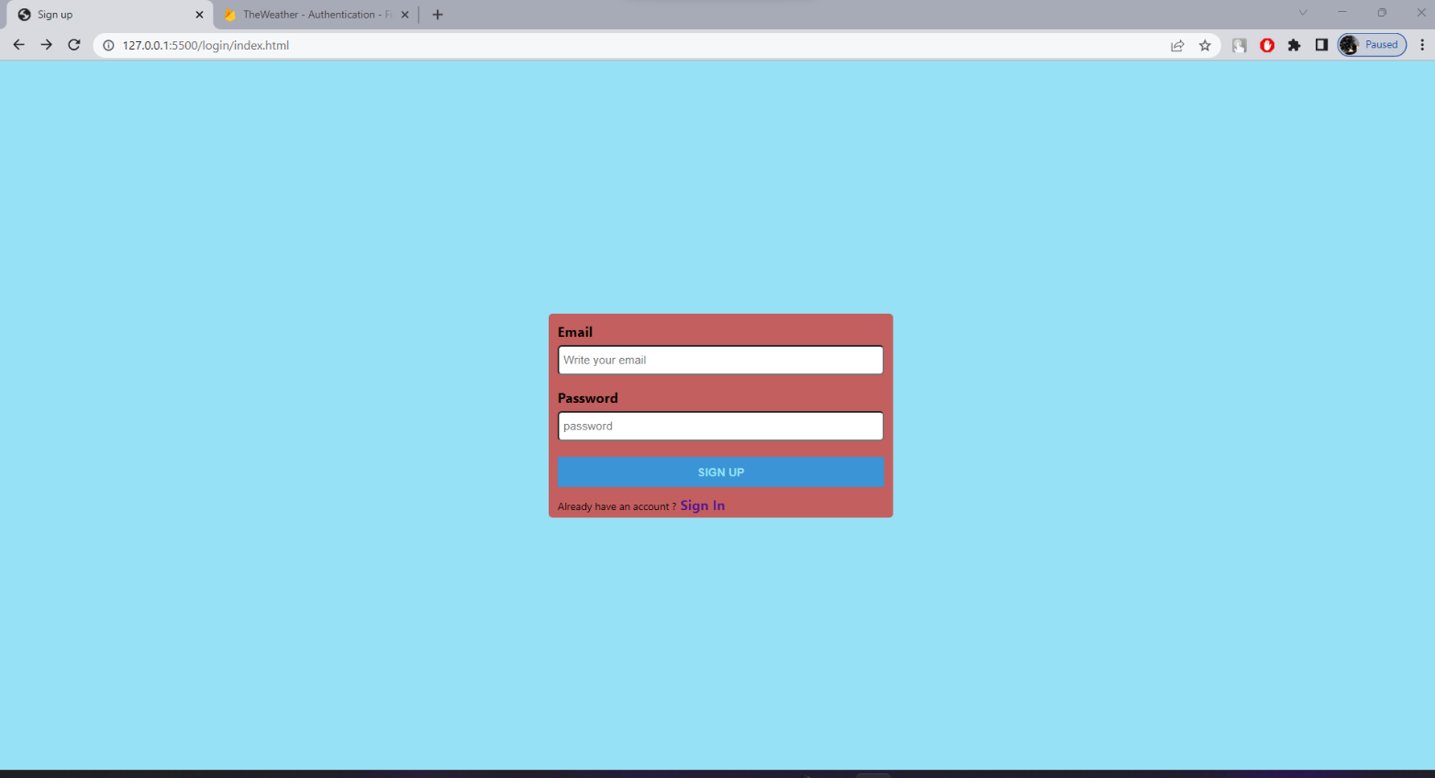

**FIG 5.1 AUTHENTICATION**

Firebase Authentication provides backend services, easy-to-use SDKs, and ready-made UI libraries to authenticate users to your app. It supports authentication using passwords, phone numbers, Email and popular identity providers like Google, Facebook and Twitter, and more.

In this tutorial, we will be learning about how to log in and authenticate in our Android application with the help of Firebase Auth phone number authentication method by sending an SMS message to the user’s phone.

Password-less phone number authentication flow will be something like this:

* + User has to enter their phone number along with the country code
  + Initiate the verification flow by tapping the CTA
  + Once the user clicks the CTA, a verification code is sent to the respective phone number.
  + The user is requested to enter the verification code, received by SMS.
  + Firebase validates the verification code, and create an account if the code is valid
  + Let’s begin the implementation.

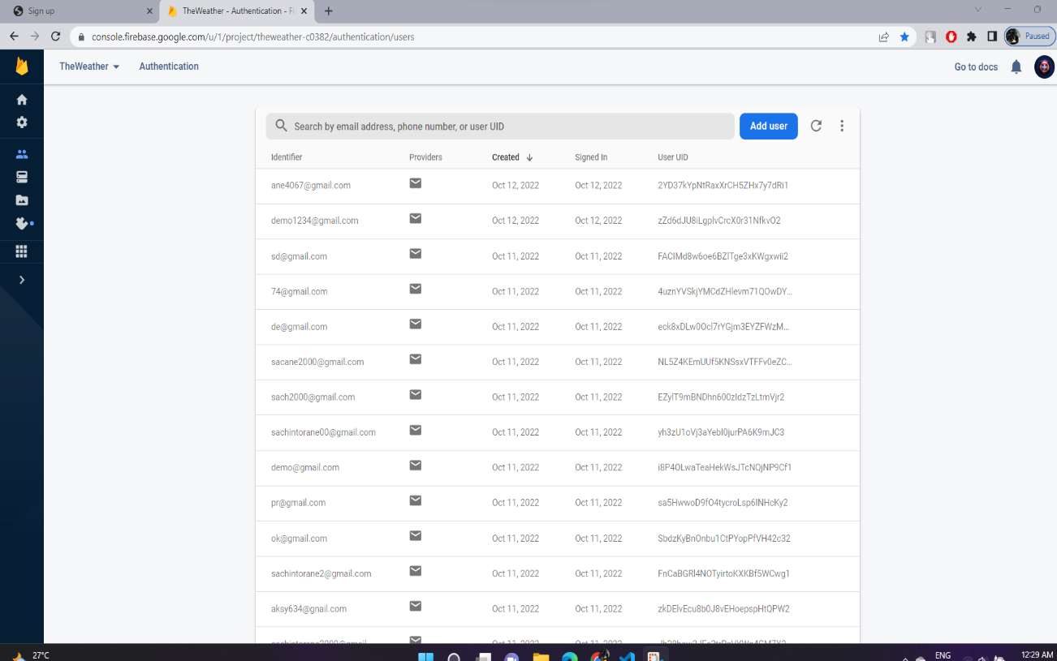

FIG 5.2 Firebase Authentication

# CHAPTER 5 TESTING

### TESTING

**The benefits of an effective test case include:**

* + - * Guaranteed good test coverage.
      * Reduced maintenance and software support costs.
      * Reusable test cases.
      * Confirmation that the software satisfies end-user requirements.
      * Improved quality of software and user experience.
      * Higher quality products lead to more satisfied customers.
      * More satisfied customers will increase company profits.

**Pre-requisite:**

1. Internet should be available.
2. Application should be installed on the device.

**Testing Table**

|  |  |  |  |  |  |  |
| --- | --- | --- | --- | --- | --- | --- |
| **TEST CASE ID** | **FEATURE** | **STEPS TO EXECUTE** | **TEST DATA INPUT** | **EXPECTED RESULT** | **ACTUAL RESULT** | **STATUS** |
| **TC_001** | **Screen flash** | **1. Enter**  **login Activity** | **Enter**  **login Activity** | **Enter login Activity** | **Enter login Activity** | **Pass** |
| **TC_002** | **Login** | 1. **Enter invalid login details.** 2. **Press Login**   **button.** | **valid mobile no and password d** | **user should be able to login** | **user is able to login** | **Pass** |

|  |  |  |  |  |  |  |
| --- | --- | --- | --- | --- | --- | --- |
| **TC_003** | **Login** | 1. **Enter invalid login details.** 2. **Press Login**   **button.** | **valid mobile no and passwor d** | **user should not be able to login.** | **user is unable to login** | **fail** |
| **TC_004** | **generate e** | **1.click on "Search** | **Generate e** | **Inter text, no, etc should be displayed.** | **-** | **Pass** |
| **TC_005** | **generat e** | **click on "generate** | **Not**  **Generat e** | **Inter text, no, etc**  **should not be displayed.** | **Access the file** | **fail** |
| **TC_006** | **Search** | **1. click on "Search btn.** | **Search** | **Open webpage** | **Display result.** | **Pass** |
| **TC_007** | **Search** | **1. click on "Search btn.** | **Search** | **Not Open Browser** | **Display result.** | **fail** |

}

**RESULT:**

**Home Page:**

The country guide web-based app show user interface and the provide different section in show images this app provide information regarding whether, country, important thing some county.

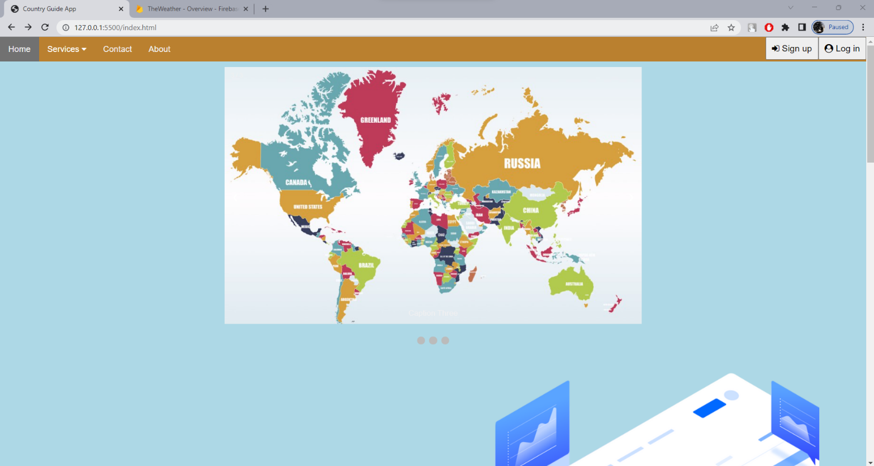

**Fig. Home Page**

**Country Guide web**

REST Countries provides a simple API for getting information about the world's nations via REST calls. These calls allow users to retrieve all available countries or to retrieve a given country's currency, capital city, calling code, region, sub-region, ISO 639-1 language, name, or country code.

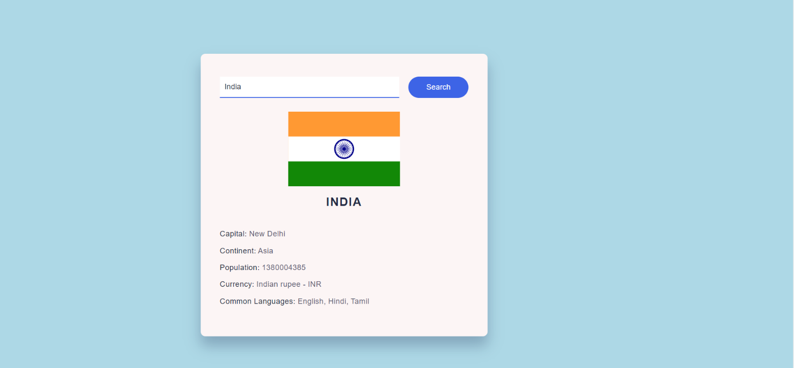

**Fig. Country Guide web**

**Grid view and footer:**

The CSS Grid Layout Module offers a grid-based layout system, with rows and columns, making it easier to design web pages without having to use floats page and give highlight information of application.

Footer represents data related to the author, data that contains copyright information or some links related to that data.

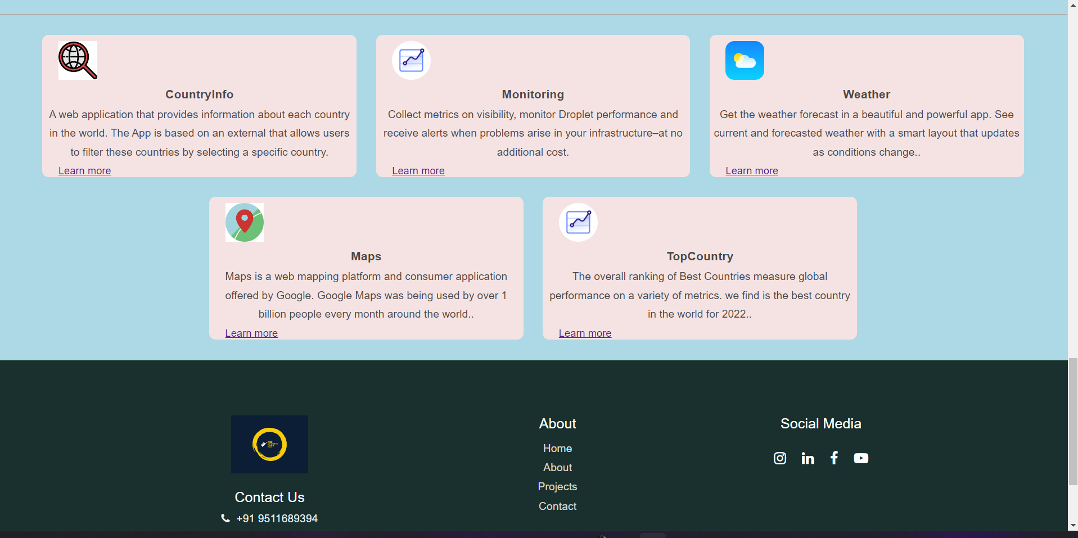

**Fig. Short Info. & Footer**

**Weather Page**:

Weather forecast app forecasts weather daily Weather forecast app is a weather channel which has accurate weather information. Weather forecast is very helpful with everybody. If you know weather information, you can prepare your plan carefully, you will be successful at work and have better life.

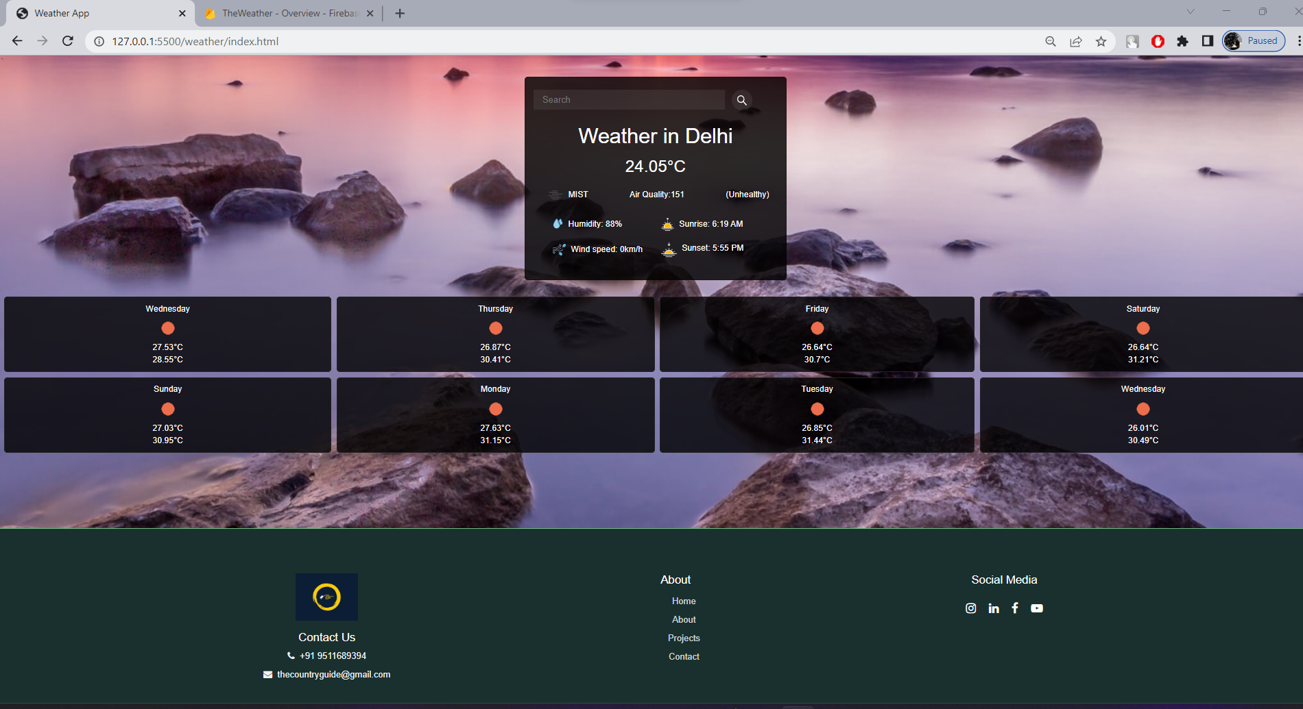

**Fig. Weather Page**

**World Map page:**

World Map Atlas is a great source of information to know about countries in the world. It offers satellite imagery, aerial photography, street maps, 360° interactive panoramic views of streets (Street View), real-time traffic conditions, and route and more.

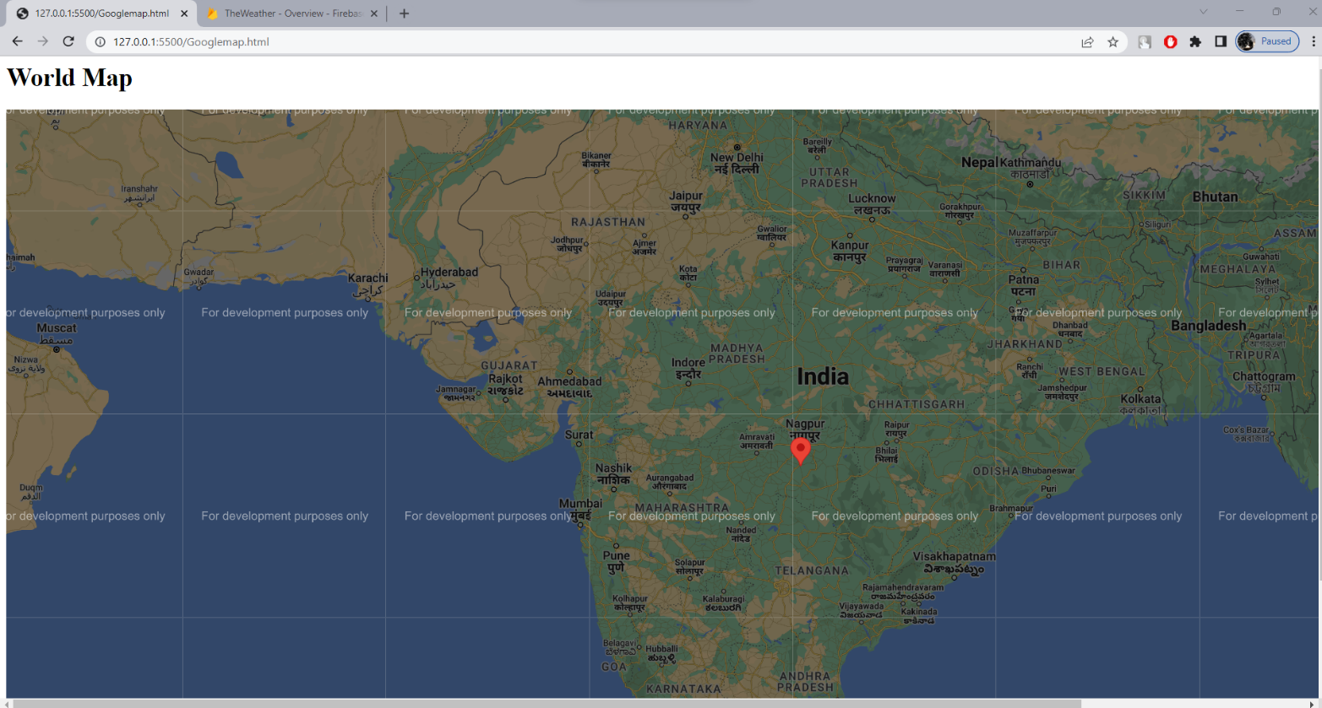

**FIG.** **World Map page**

**Historical places Page:**

A historic page is an official location where pieces of political, military, cultural, or social history have been preserved due to their cultural heritage value. Historic sites are usually protected by law, and many have been recognized with the official national historic site.

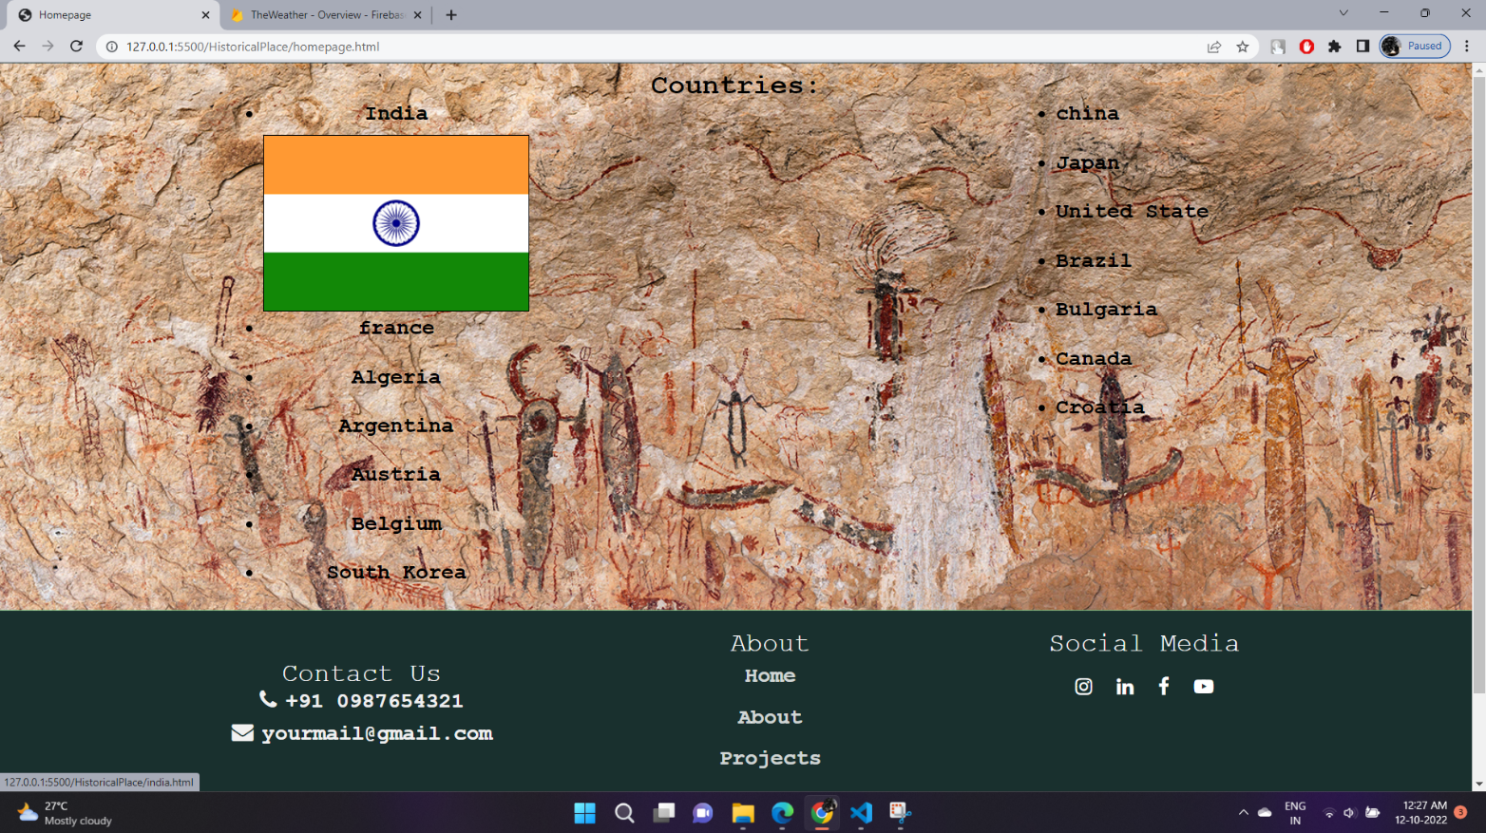

**Fig.** **Historical places Page**

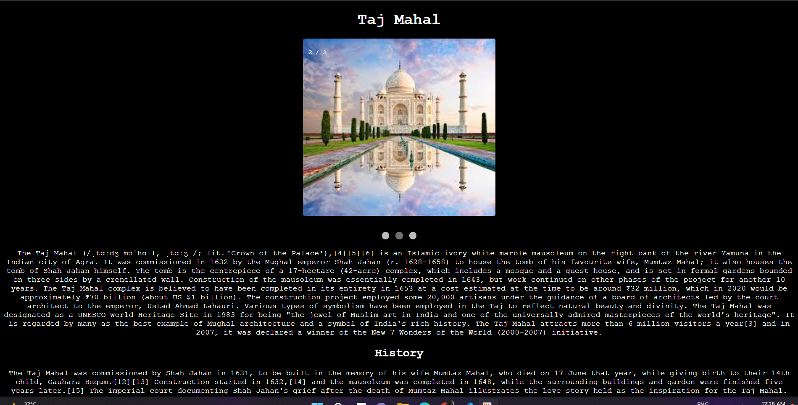

**Fig. Historical place Information**

**Contact forms:**

Contact forms are a must-have for any website and every business for sure and with Might Forms, you can easily customize the colors and fields however you like.

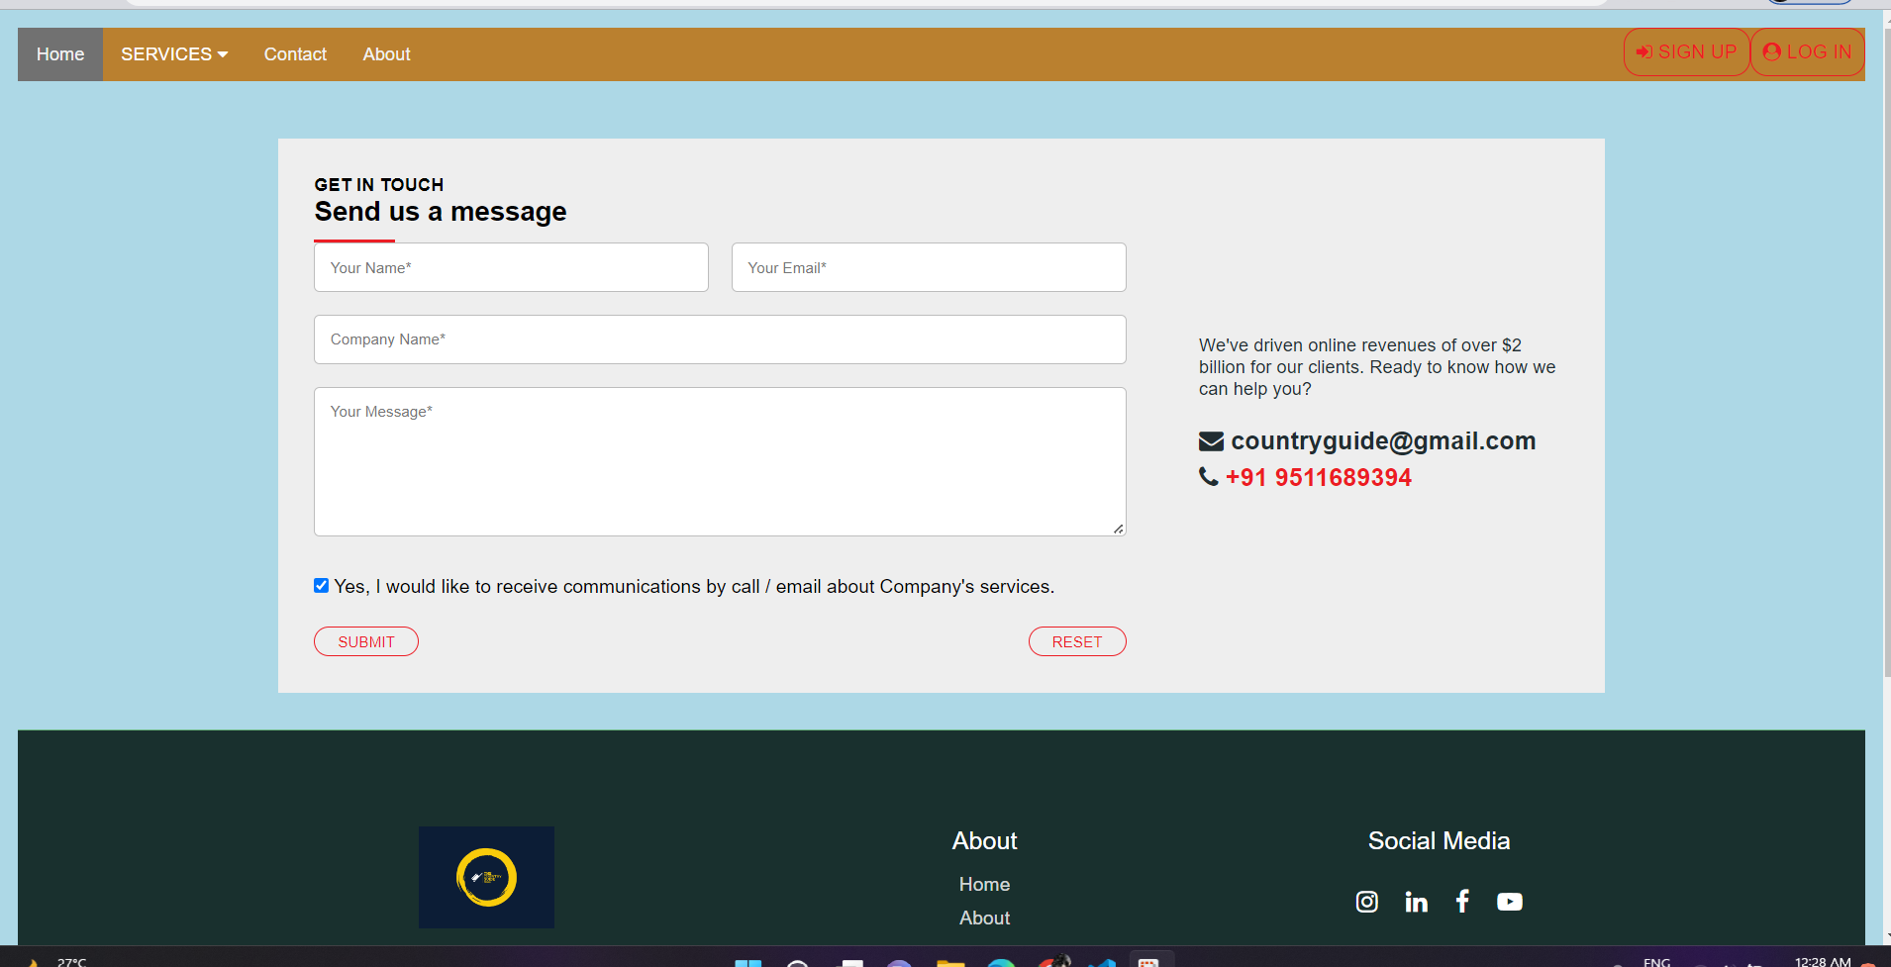

**Fig. Contact Page**

**Fig. Sign in Page:**

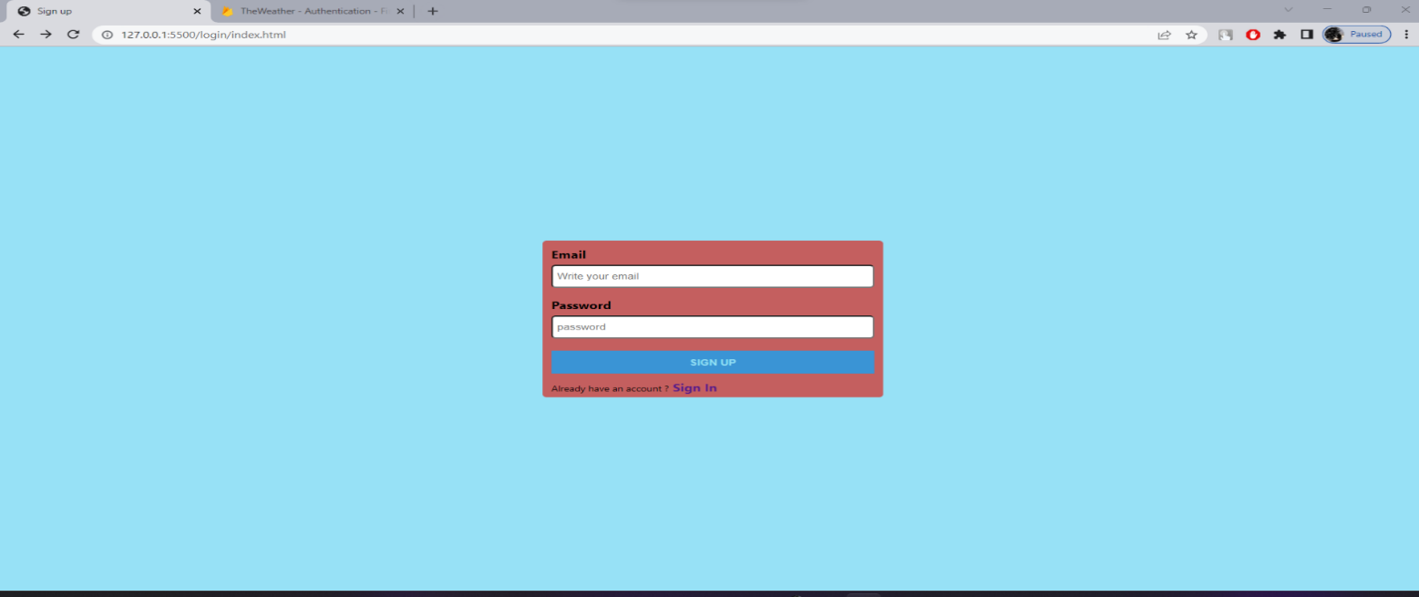The login page allows a user to gain access to an application by entering their username and password or by authenticating using a social media login.

**Fig Sign in Page**

**Firebase information:**

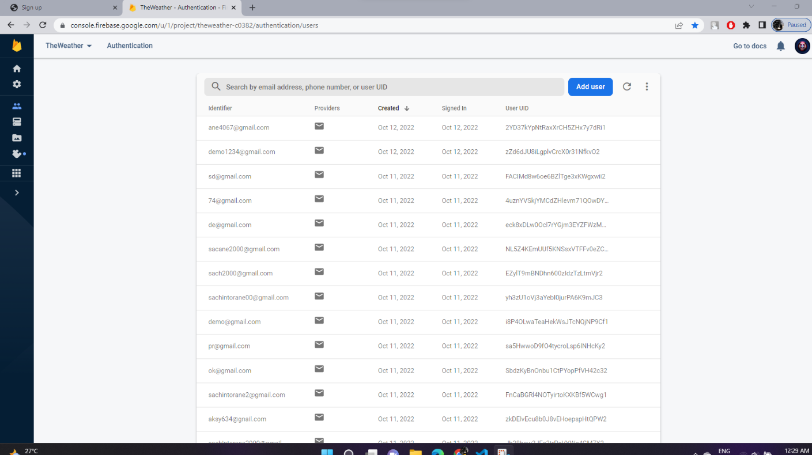Google Firebase is a Google-backed application development software that enables developers to develop iOS, Android and Web apps. Firebase provides tools for tracking analytics, reporting and fixing app crashes, creating marketing and product experiment.

**Fig. Firebase information**

**Acknowledgments**

I thank my college Principal Dr. V. N. Pawar sir for providing the required resources for the development of the project. I would also like to thank HOD Prof. S. P. Pawar for suggesting such a great project topic for departmental purposes. My sincere thanks to my Project Guide (name of guide) for helping, suggesting new ideas and guiding me throughout the semester. I am also grateful to all the faculty members for their support and encouragement.

**Date:**

# Conclusion: -

# A city guide app has been the best reliable friends for the tourists and others who visit new places and have no idea about it. It helps you in searching all the important places that are important from the tourist destination’s point of view by providing all the details about it.

# You can also find the local transport easily and know the timings to make the necessary preparations in advance. You can check-out the essential events and happenings taking place around the city.

# This website is the need of the time.

# It is part of a redefinition of how we as a transmit knowledge and values to younger generations of students.

# The code we have implemented for our project is working well to the best of our knowledge.

# This project provided an opportunity to learn the various concepts of the subject in detail.

**Appendix**

<!DOCTYPE html>

<html lang="en">

<head>

    <meta charset="UTF-8">

    <meta http-equiv="X-UA-Compatible" content="IE=edge">

    <meta name="viewport" content="width=device-width, initial-scale=1.0">

    <link rel="stylesheet" href="https://cdnjs.cloudflare.com/ajax/libs/font-awesome/4.7.0/css/font-awesome.min.css">

    <title>Country Guide App</title>

    <link rel="stylesheet" href="style.css" />

    <link rel="stylesheet" href="slideshow.css">

    <link rel="stylesheet" href="banner.css">

    <link rel="stylesheet" href="footer.css">

</head>

<body>

    <header>

<div class="topnav" id="myTopnav">

  <a href="#home" class="active">Home</a>

  <div class="subnav">

    <button class="subnavbtn">Services <i class="fa fa-caret-down"></i></button>

    <div class="subnav-content">

      <a href="weather/index.html">Weather</a>

      <a href="Googlemap.html">Maps</a>

      <a href="TheContinents.html"> 7 Continents</a>

      <a href="HistoricalPlace/homepage.html">Top Country</a>

    </div>

  </div>

    <a href="contact.html" >Contact</a>

    <a href="about.html" >About</a>

<button class=" login-btn" onclick="myfunction()" type="submit"> <i class="fa fa-user-circle"  aria-hidden="true"></i> Log in</button>

<button class=" login-btn" onclick="myfunction()" type="submit"><i class="fa fa-sign-in" aria-hidden="true"></i>  Sign up</button>

<script>

  function myfunction(){

    location.replace('login/index.html')

  }

</script>

</div>

    </header>

   <!-- Slideshow container -->

<div class="slideshow-container">

    <!-- Full-width images with number and caption text -->

    <div class="mySlides fade">

      <div class="numbertext">1 / 3</div>

      <img src="https://previews.123rf.com/images/missfortuna/missfortuna1701/missfortuna170100042/69990090-vector-map-icon-with-pin-pointers-flat-style-eps-jpg.jpg" style="width:100%">

      <div class="text">Caption Text</div>

    </div>

    <div class="mySlides fade">

      <div class="numbertext">2 / 3</div>

      <img src="Images/2.jpg" style="width:100%">

      <div class="text">Caption Two</div>

    </div>

    <div class="mySlides fade">

      <div class="numbertext">3 / 3</div>

      <img src="https://npr.brightspotcdn.com/dims4/default/fce09b3/2147483647/strip/true/crop/1500x924+0+70/resize/880x542!/quality/90/?url=http%3A%2F%2Fnpr-brightspot.s3.amazonaws.com%2Flegacy%2Fsites%2Fvpr%2Ffiles%2F201701%2FMap-countries-istock-ZarkoCvijovic-20170104.jpg" style="width:100%">

      <div class="text">Caption Three</div>

    </div>

    <!-- Next and previous buttons -->

    <a class="prev" onclick="plusSlides(-1)">&#10094;</a>

    <a class="next" onclick="plusSlides(1)">&#10095;</a>

  </div>

  <br>

  <!-- The dots/circles -->

  <div style="text-align:center">

    <span class="dot" onclick="currentSlide(1)"></span>

    <span class="dot" onclick="currentSlide(2)"></span>

    <span class="dot" onclick="currentSlide(3)"></span>

  </div>

<!--banner-->

<section class="banner">

  <div class="container">

    <div class="banner-text">

      <h1 class="banner-heading">Manage</h1>

      <p><strong>A web application that provides information about each country in the world. </strong>The App is based on an external that allows users to filter these countries by selecting a specific country.</p>

      <button onclick="myfunction()" class="banner-btn">Sign Up</button>

      <script>

        function myfunction(){

          location.replace('login/index.html')

          alert("Go and login...")

        }

      </script>

    </div>

  </div>

  <img class="banner-image" src="https://preview.ibb.co/bMi5Y6/banner_img.png" alt="monitoring" >

</section>

<!-- serach -btn-->

<br>

<div class="container-search">

  <div class="search-wrapper">

    <input  type="text"id="country-inp" placeholder="Enter a country name here..." list="Countries"/>

    <datalist id="Countries">

      <option value="Afghanistan">Afghanistan</option>

      <option value="Anguilla">Anguilla</option>

      <option value="Armenia">Armenia</option>

      <option value="Australia">Australia</option>

      <option value="Azerbaijan">Azerbaijan</option>

      <option value="Bangladesh">Bangladesh</option>

      <option value="Belgium">Belgium</option>

      <option value="Canada">Canada</option>

      <option value="China">China</option>

      <option value="Egypt">Egypt</option>

      <option value="England">England</option>

      <option value="France">France</option>

      <option value="Germany">Germany</option>

      <option value="India">India</option>

      <option value="Italy">Italy</option>

      <option value="Maldives">Maldives</option>

      <option value="Mexico">Mexico</option>

      <option value="Nepal">Nepal</option>

      <option value="Pakistan">PakistanR</option>

      <option value="Saudi Arabia">Saudi Arabia</option>

      <option value="Singapore">Singapore</option>

      <option value="Spain">Spain</option>

      <option value="Turkey">Turkey</option>

      <option value="Ukraine">Ukraine</option>

      <option value="Uzbekistan">Uzbekistan</option>

      <option value="Zimbabwe">Zimbabwe</option>

      <option value="United States">United States*

      <option value="Korea">Korea</option>

      <option value="Japan">Japan</option>

      <option value="North Korea">North Korea,</option>

      <option value="South Korea">South Korea"</option>

  </datalist>

    <button id="search-btn">Search</button>

  </div>

  <div id="result"></div>

</div>

<br><br><br><br><br><br><br><br><br><br><br><br><br><br><br><br><br><br><br><br><br><br><br>

<hr border-top: 3px dotted #bbb;>

<!-- card view-->

<div class="row">

  <div class="column">

    <div class="card">

     <img class="card-icon" src="https://encrypted-tbn0.gstatic.com/images?q=tbn:ANd9GcQniShSd1PgRJYO2zHT-IMLndXlznpyH_QPGMvIKywo_a3bKBLjDsnm02DqgKOLauBEXRM&usqp=CAU" alt="monitoring" >

      <h3 class="card-title">CountryInfo</h3>

      <p class="card-text">A web application that provides information about each country in the world. The App is based on an external that allows users to filter these countries by selecting a specific country.</p>

      <a class="card-link" href="#">Learn more</a>

  </div>

</div>

<div class="column">

  <div class="card">

   <img class="card-icon" src="https://image.ibb.co/cFV8mR/monitoring.png" alt="monitoring" >

    <h3 class="card-title">Monitoring</h3>

    <p class="card-text">Collect metrics on visibility, monitor Droplet performance and receive alerts when problems arise in your infrastructure–at no additional cost.</p>

    <a class="card-link" href="#">Learn more</a>

</div>

</div>

<div class="column">

  <div class="card">

   <img class="card-icon" src="https://iconape.com/wp-content/files/cw/116300/svg/weather-ios.svg" alt="monitoring" >

    <h3 class="card-title">Weather</h3>

    <p class="card-text">Get the weather forecast in a beautiful and powerful app. See current and forecasted weather with a smart layout that updates as conditions change..</p>

    <a class="card-link" href="../weather/index.html">Learn more</a>

</div>

</div>

</div>

<div class="row-1">

  <div class="column">

    <div class="card">

     <img class="card-icon" src="https://encrypted-tbn0.gstatic.com/images?q=tbn:ANd9GcRFM6xQU2ieNJT8--M9169e-IZ7ELKyzngQJA&usqp=CAU" alt="monitoring" >

      <h3 class="card-title">Maps</h3>

      <p class="card-text">Maps is a web mapping platform and consumer application offered by Google.  Google Maps was being used by over 1 billion people every month around the world..</p>

      <a class="card-link" href="../Googlemap.html">Learn more</a>

  </div>

</div>

<div class="column">

  <div class="card">

   <img class="card-icon" src="https://image.ibb.co/cFV8mR/monitoring.png" alt="monitoring" >

    <h3 class="card-title">TopCountry</h3>

    <p class="card-text">The overall ranking of Best Countries measure global performance on a variety of metrics. we find is the best country in the world for 2022..</p>

    <a class="card-link" href="../HistoricalPlace/homepage.html">Learn more</a>

</div>

</div>

</div>

<footer>

  <section id="footer">

    <div class="main-footer">

      <div class="logoinfo" data-aos="fade-up">

<div><img src="Images/logo.png" width="120px" height="120%"></div>

        <div class="contact-details">

          <h1>Contact Us</h1>

          <li>

            <div class="fa fa-phone"></div><a href="tel:+919511689394">+91 9511689394</a></li>

          <li>

            <div class="fa fa-envelope"></div><a href="mailto:collegeinfopk02@gmail.com">thecountryguide@gmail.com</a></li>

          </li>

      </div>

    </div>

    <div class="com " data-aos="fade-up">

      <h1>About</h1>

      <ul>

        <li><a href="index.html">Home</a></li>

        <li><a href="about.html">About</a></li>

        <li><a href="#">Projects</a></li>

        <li><a href="contact.html">Contact</a></li>

      </ul>

    </div>

    <div class="info" data-aos="fade-up">

      <h1>Social Media</h1>

      <div class="sociallogos">

        <div class="logobox">

          <a href="#" class="fa fa-instagram"></a>

          <a href="#" class="fa fa-linkedin"></a>

          <a href="#" class="fa fa-facebook"></a>

          <a href="#" class="fa fa-youtube-play"></a>

        </div>

      </div>

    </div>

    </div>

  <footer>© Your Copyright 2022 All Rights Reserved

    <br>

    <p>The County Guide App 2.0</p>

  </footer>

  </section>

</footer>

  <script src="jsfile/slideshow.js"></script>

  <script src="jsfile/api.js"></script>

  <script src="jsfile/api.js"></script>

  <script src="weather/assets/js/Capitals.js"></script>

  <script src="weather/assets/js/script.js"></script>

</body>

</html>

let searchBtn = document.getElementById("search-btn");

let countryInp = document.getElementById("country-inp");

searchBtn.addEventListener("click", () => {

  let countryName = countryInp.value;

  let finalURL = `https://restcountries.com/v3.1/name/${countryName}?fullText=true`;

  console.log(finalURL);

  fetch(finalURL)

    .then((response) => response.json())

    .then((data) => {

      //   console.log(data[0]);

      //   console.log(data[0].capital[0]);

      //   console.log(data[0].flags.svg);

      //   console.log(data[0].name.common);

      //   console.log(data[0].continents[0]);

      //   console.log(Object.keys(data[0].currencies)[0]);

      //   console.log(data[0].currencies[Object.keys(data[0].currencies)].name);

      //   console.log(

      //     Object.values(data[0].languages).toString().split(",").join(", ")

      //   );

      result.innerHTML = `

        <img src="${data[0].flags.svg}" class="flag-img">

        <h2>${data[0].name.common}</h2>

        <div class="wrapper">

            <div class="data-wrapper">

                <h4>Capital:</h4>

                <span>${data[0].capital[0]}</span>

            </div>

        </div>

        <div class="wrapper">

            <div class="data-wrapper">

                <h4>Continent:</h4>

                <span>${data[0].continents[0]}</span>

            </div>

        </div>

         <div class="wrapper">

            <div class="data-wrapper">

                <h4>Population:</h4>

                <span>${data[0].population}</span>

            </div>

        </div>

        <div class="wrapper">

            <div class="data-wrapper">

                <h4>Currency:</h4>

                <span>${

                  data[0].currencies[Object.keys(data[0].currencies)].name

                } - ${Object.keys(data[0].currencies)[0]}</span>

            </div>

        </div>

         <div class="wrapper">

            <div class="data-wrapper">

                <h4>Common Languages:</h4>

                <span>${Object.values(data[0].languages)

                  .toString()

                  .split(",")

                  .join(", ")}</span>

            </div>

        </div>

      `;

    })

    .catch(() => {

      if (countryName.length == 0) {

        result.innerHTML = `<h3>The input field cannot be empty</h3>`;

      } else {

        result.innerHTML = `<h3>Please enter a valid country name.</h3>`;

      }

    });

});

@import url('https://fonts.googleapis.com/css2?family=Montserrat:wght@400;500;600;700&display=swap');

*{

  margin:0;

  padding:0;

  box-sizing:border-box;

}

body{

  font-family: 'Montserrat', sans-serif;

}

.main-footer {

  padding: 70px 0;

  display: flex;

  justify-content: space-evenly;

  background-color: #19302E;

}

.main-footer ul {

  list-style: none;

}

.main-footer h1 {

  font-size: 22px;

  line-height: 117%;

  color: #ffffff;

  margin-bottom: 10px;

  font-weight: 500;

}

.main-footer h2 {

  color: #ffffff;

  font-weight: 500;

}

.main-footer ul li a {

  color: #ffffffcc;

  text-decoration:none;

}

footer {

  background-color: #19302E;

  border-top: 1px solid #6EB981;

  font-size: 17px;

  padding: 15px 5px;

  color: #ffffff;

  text-align: center;

}

footer a {

  text-decoration: none;

  color: #ffffff;

}

.logoinfo p {

  color: #6EB981;

  font-size: 17px;

  margin-top: 5px;

}

.contact-details {

  margin-top: 20px;

}

.contact-details li {

  list-style: none;

  margin: 10px 0;

}

.contact-details li a {

  text-decoration:none;

  color: #f1f1f1;

}

.contact-details .fa {

  color: #f1f1f1;

  margin-right: 10px;

}

.sociallogos{

  padding:20px 0;

}

.sociallogos .logobox a{

  padding:0 10px;

  text-decoration:none;

  color:#ffffff;

  font-size:22px;

}

.com ul li{

  padding:5px 0;

}

@media only screen and (max-width: 749px) {

  .main-footer {

    padding:20px;

    display:grid;

    grid-template-columns: 1fr 1fr;

  }

    .info{

      padding:20px 0;

  }

}

@media (max-width: 480px)

**REFERANCES :-**

* + - <https://restcountries.com/>
    - <https://openweathermap.org/api>
    - <https://www.google.com/maps>
    - <https://firebase.google.com/>
    - [**https://www.w3schools.com/html/default.asp**](https://www.w3schools.com/html/default.asp)
    - **[https://www.javapoint.com](http://www.javapoint.com/)**